ME 4160 Controls Lab 6

12/03/18

Objective
The objective of this experiment is setup derivative and integrator block and PID controller.
Procedure
The analog and mechanical unit were set up in the derivative block system for observation in figure 1.

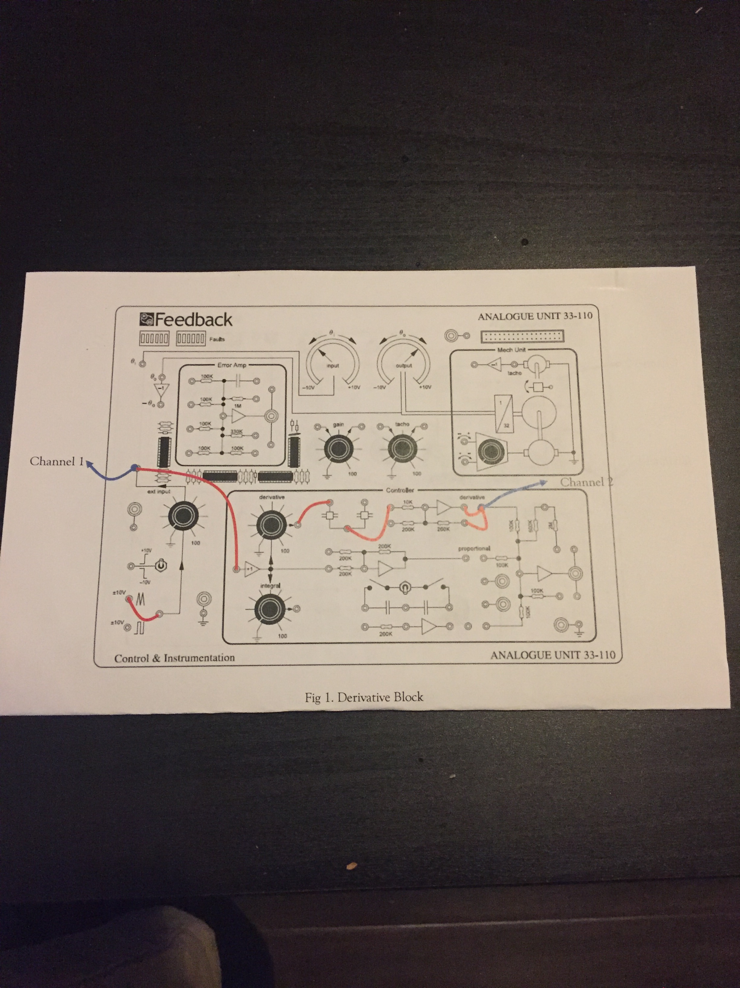

Figure. 1. Derivative Block

The p3 and p4 were set to 100% gain, and the frequency was set to 0.6Hz. A triangular wave and sinusoidal wave were applied as the input voltage. Input and output voltages were compared at channel 1 and channel 2.
The analog and mechanical unit were set up in the integrator block system as shown in Figure 2.
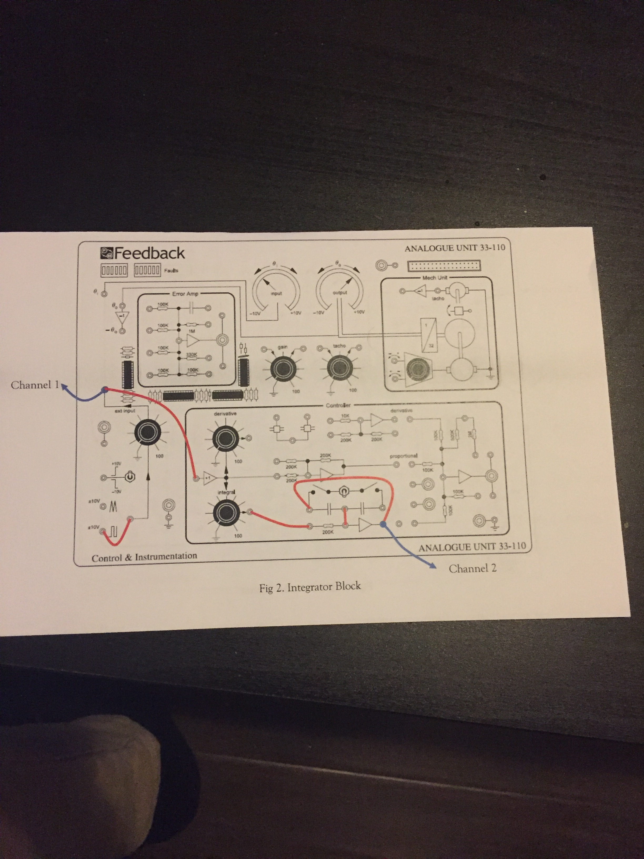
Figure 2. Integrator Block

The P3 value was set at 30% gain and the P5 value was set to 100% gain, and input frequency value was set to 0.6Hz. And again square wave and triangular waves were supplied as input voltages. Moreover, SW3 was set up down and up. And input and output voltages at channel 1 and channel 2 were compared.
After that, the analog and mechanical units were set up for the PD controller as shown in Figure 3.
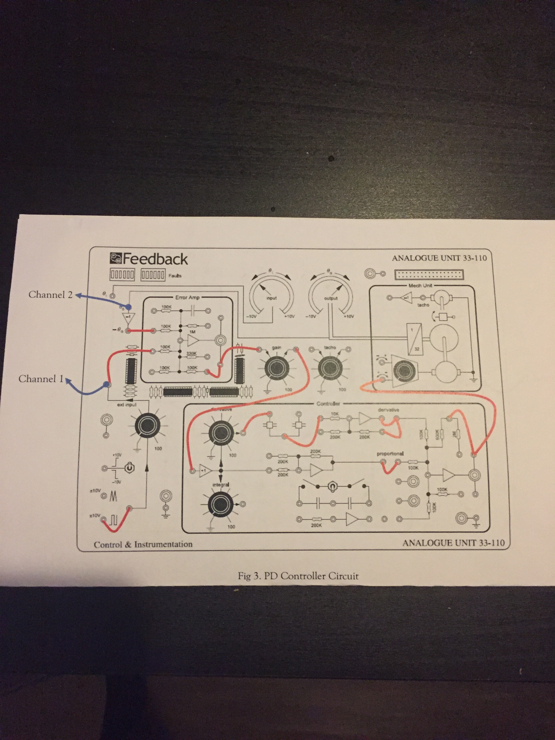
Figure 3. PD controller circuit
The P1 was set at 100% gain, P3 was set to 50% gain, P4 was set to 0 %, and the frequency of the input set to 0.2 Hz. WhenP4=0 so that means the P is the controller. When P4=30%,50%,70% and 100% so that means PD controller.
Next, the analog and mechanical unit was set up for PID controller circuit.

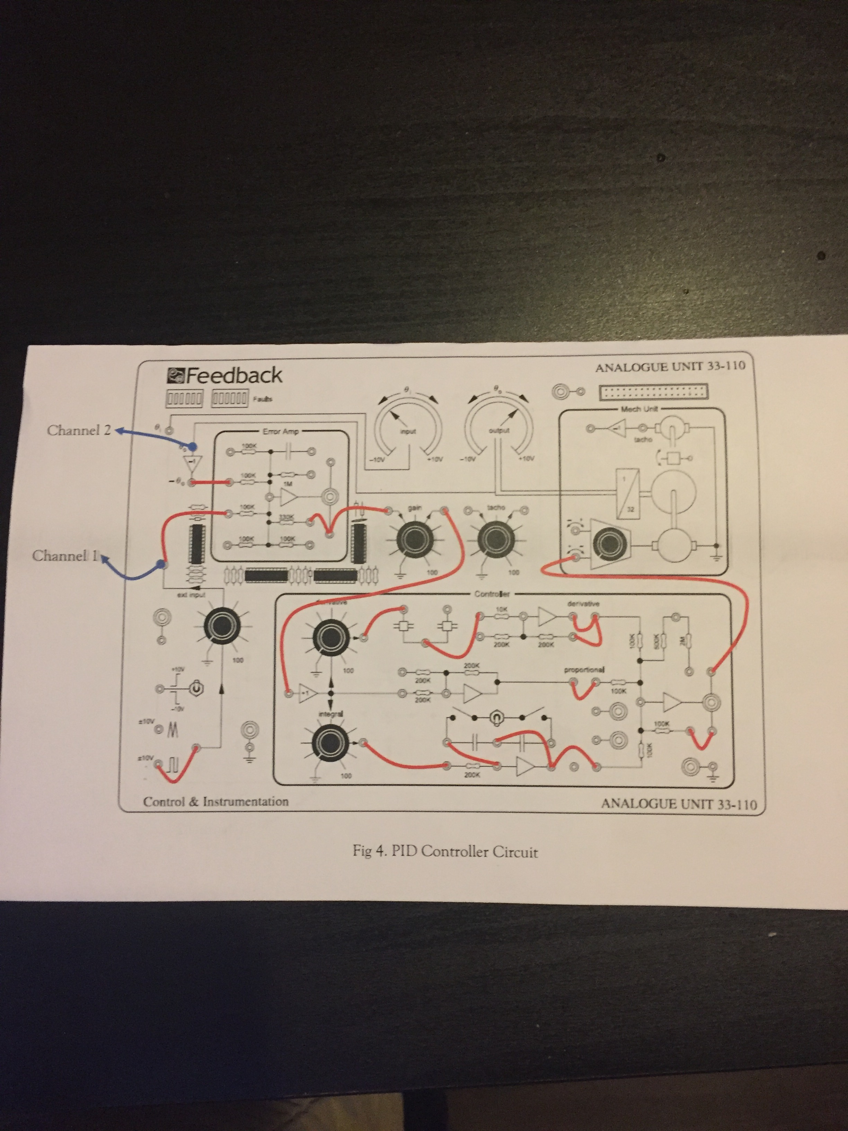
Figure 4. PID controller
The P1 was set at 100% gain, P3 was set to 50% gain, P4, P5 was set to 0 %, and the frequency of the input set to 0.1 Hz. P4 and P5 gain percentages were set by trial and error method in order to find the best setting.
Results:
Observation 1:
The following figure is related to observation 1 which is the derivative block. As shown in figure 5 below, signal transmitting was started with triangular wave channel 1.
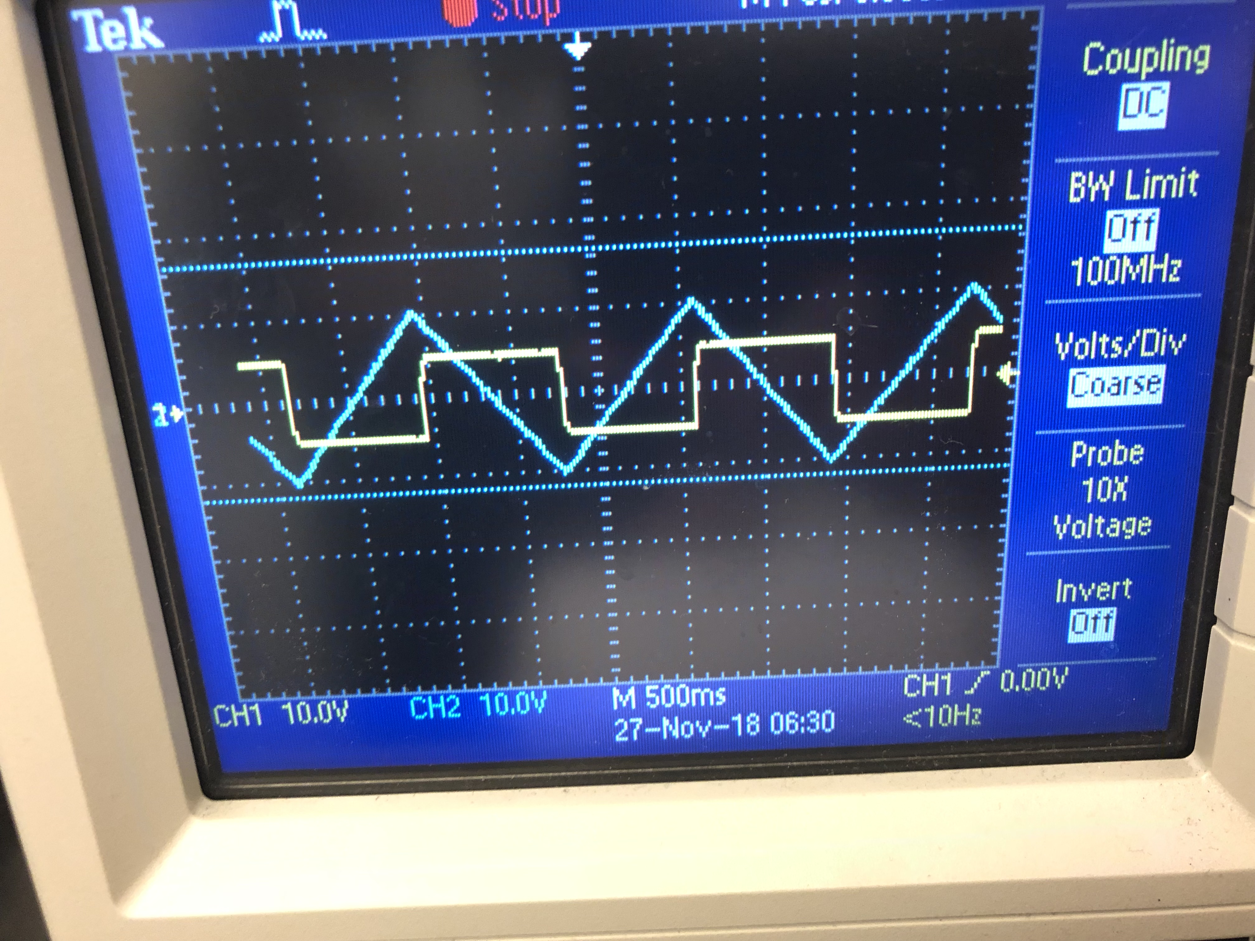
Figure. 5. Triangular wave
As shown in figure 5, Signal transmitting was started with triangular wave channel 2.

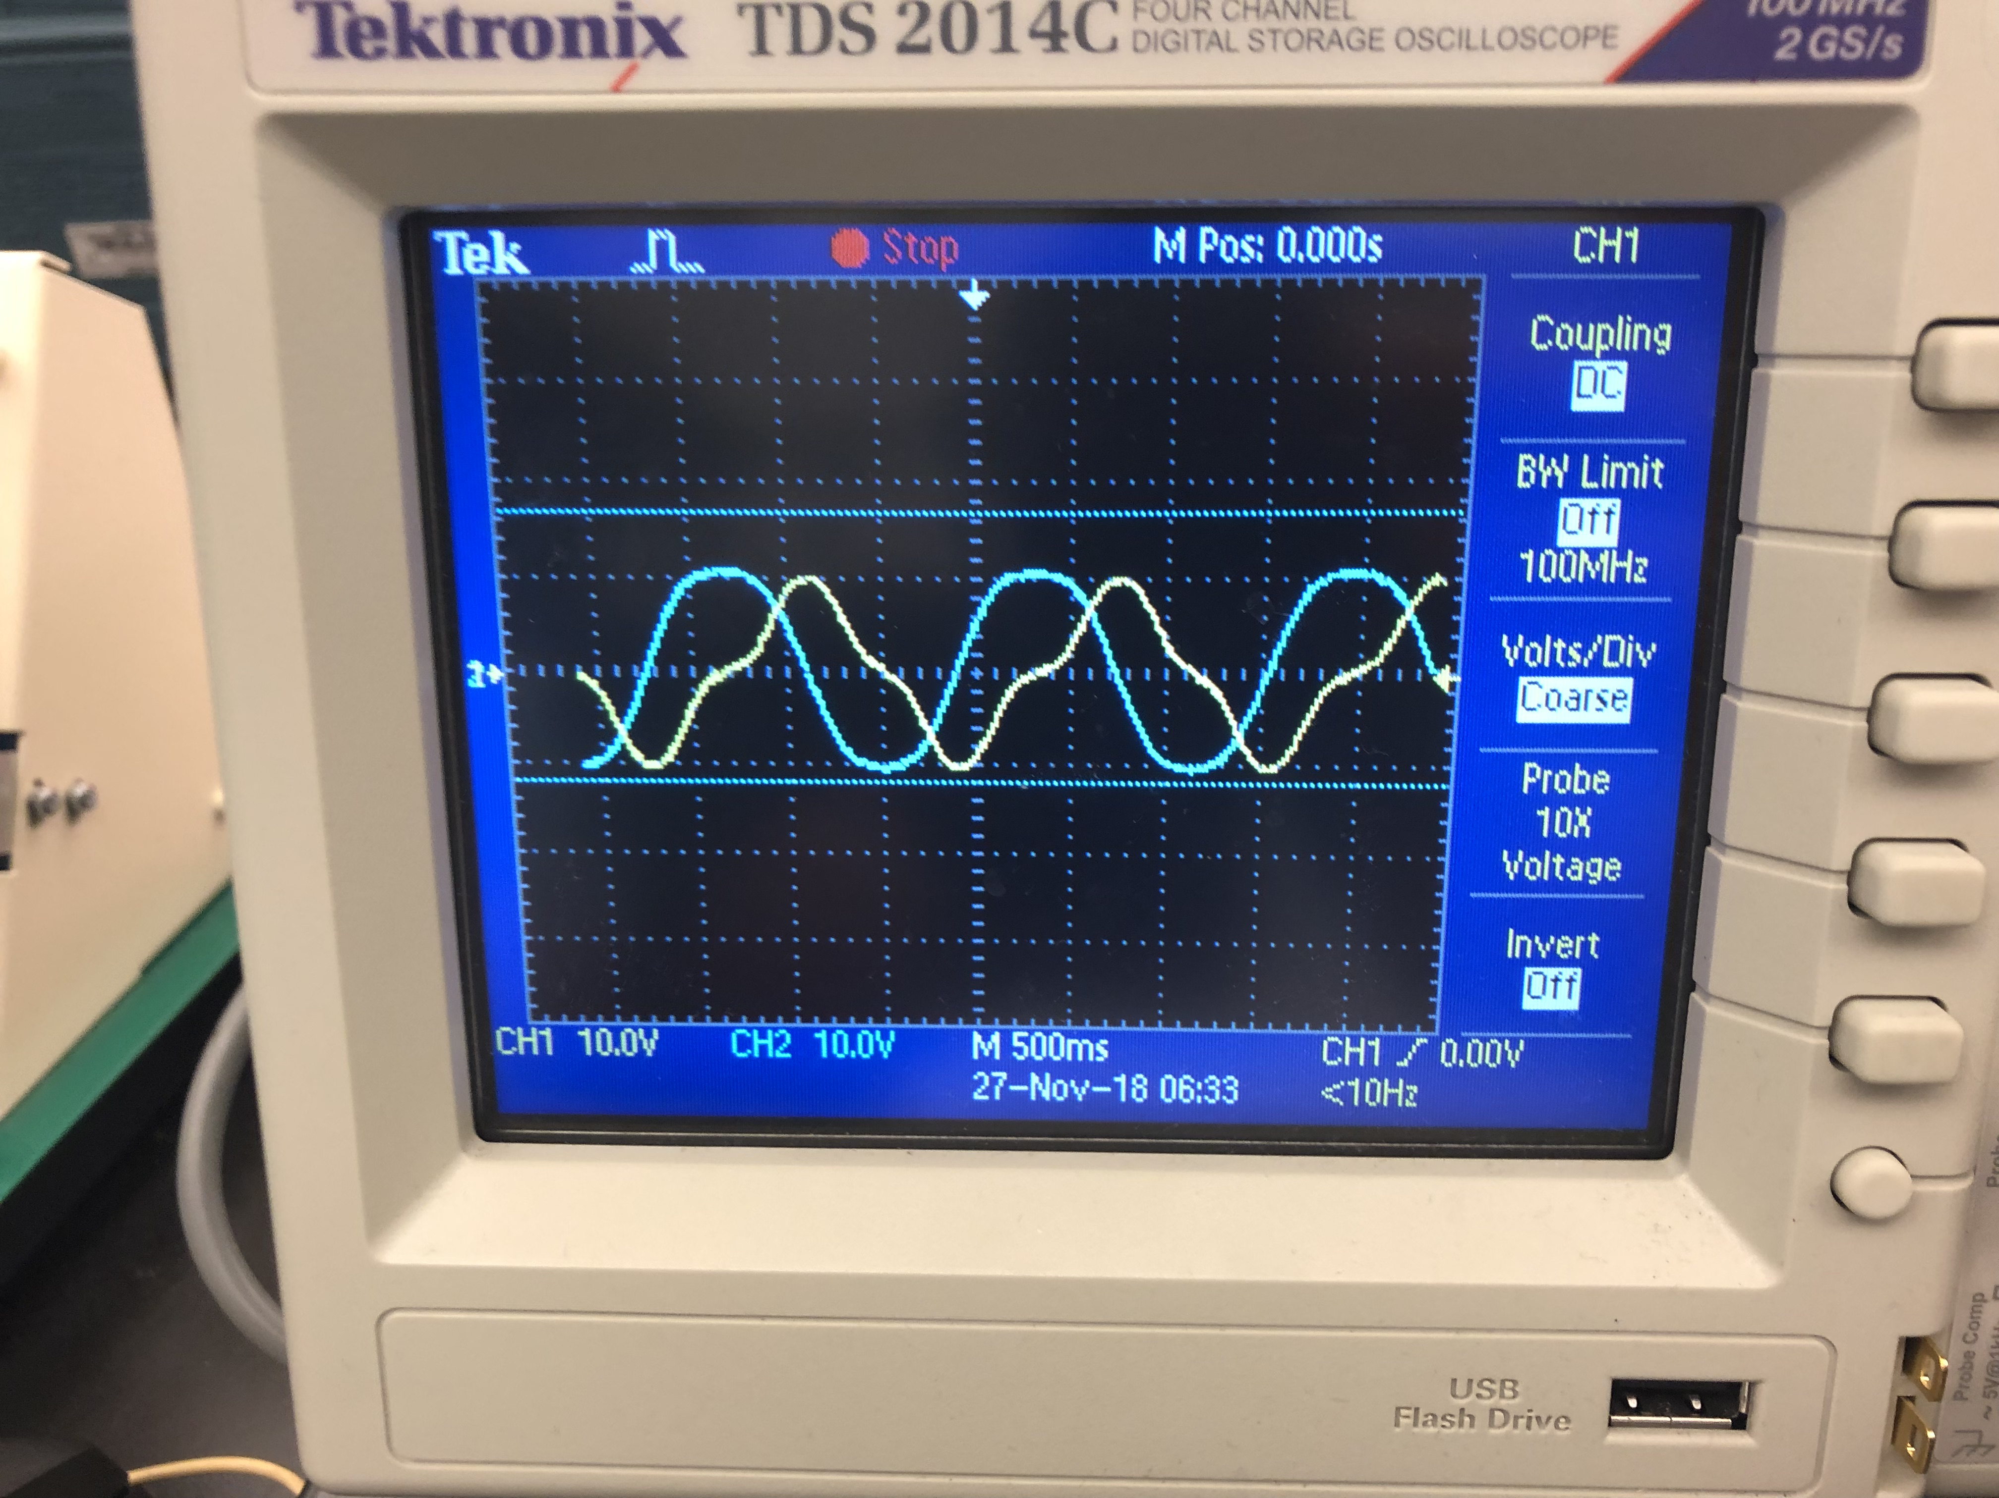Figure. 6. Sinusoidal wave channel 1
As shown in figure 6, Signal was applied with sinusoidal wave channel 2.
Observation 2:
The following figures are related to observation 2, which is the integrator block. As shown in figure 7, signal transmitting was started with square wave channel 1.
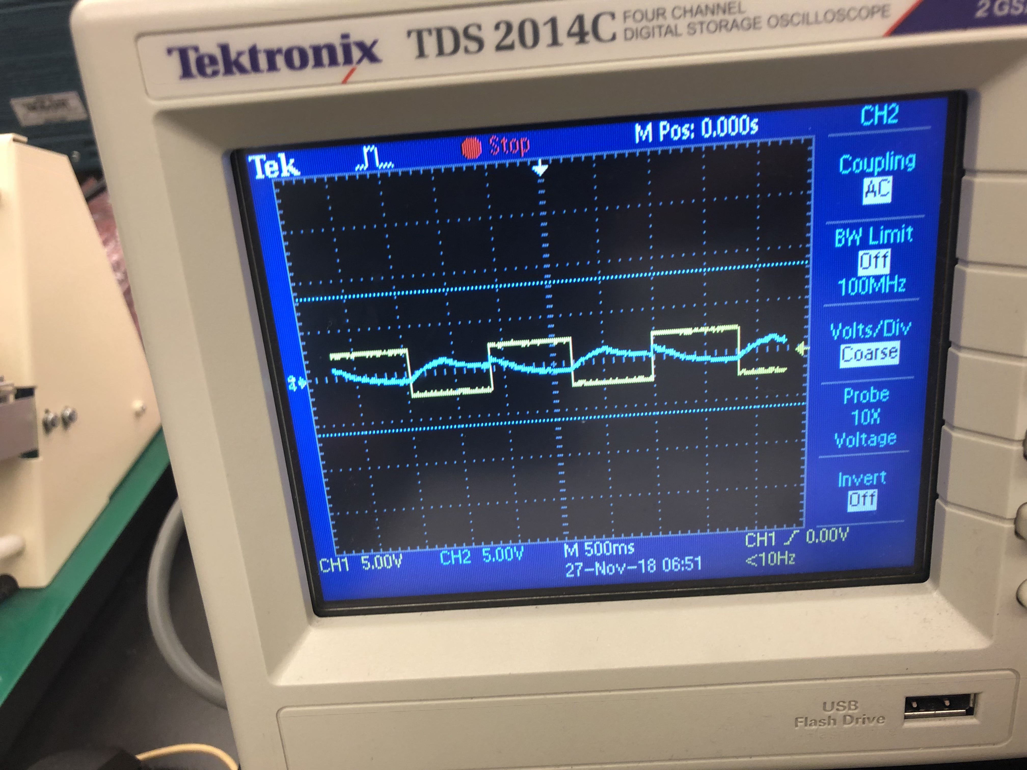
Figure 7. Square wave channel 1
As shown in figure 8 below, signal transmitting was started with triangular wave channel 2.
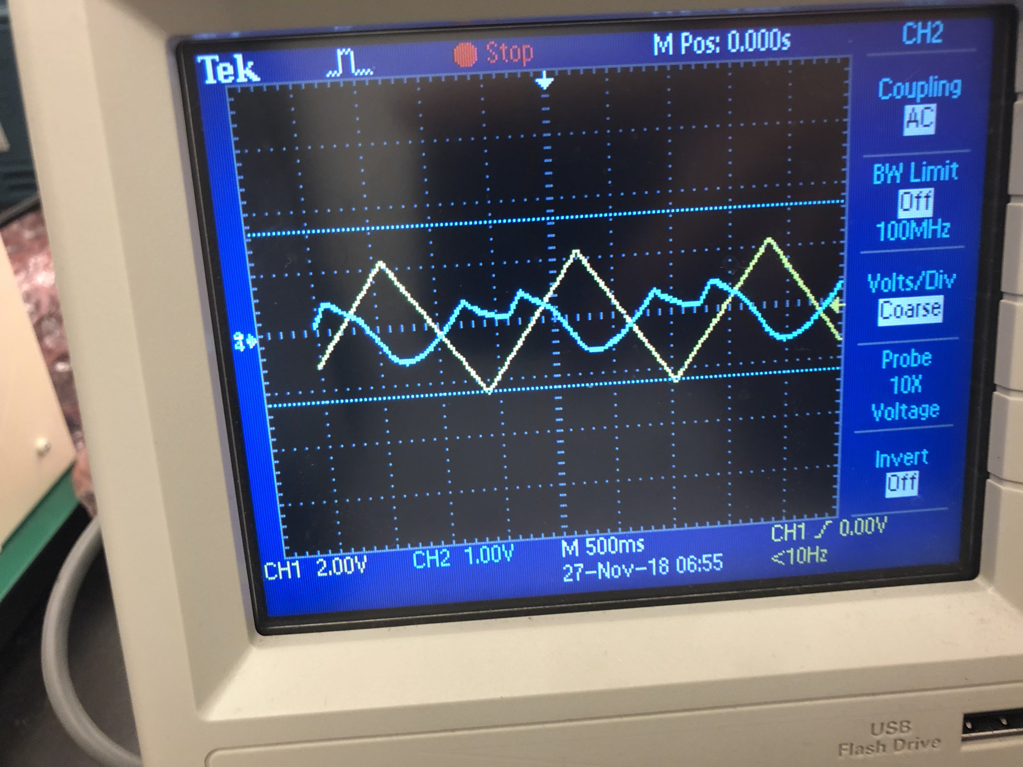
Figure. 8. Triangular wave channel 2

PD Controller:
The figures below are related with PD controller.
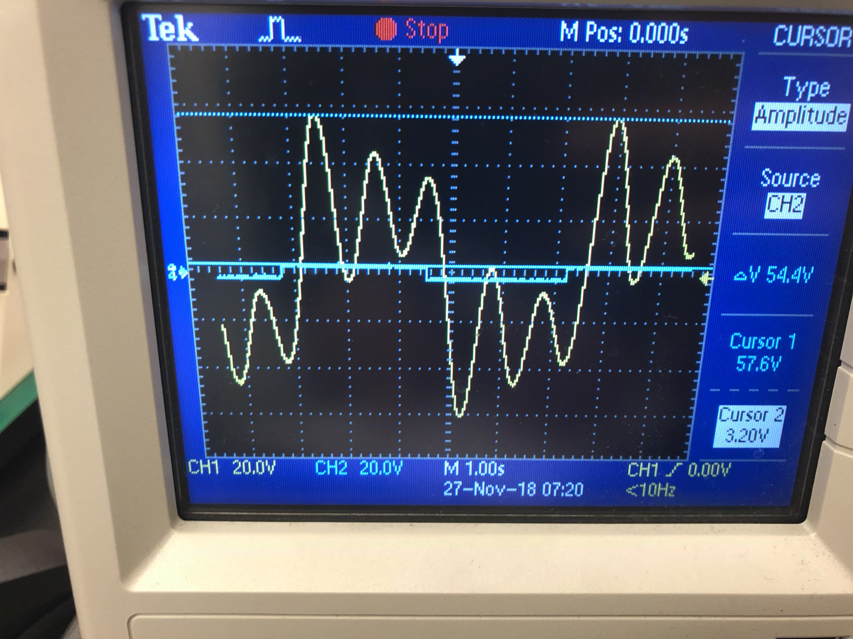
Figure. 9. P4 = 0%

When P4 = 30% the oscilloscope behavior can be seen from figure 10 below.
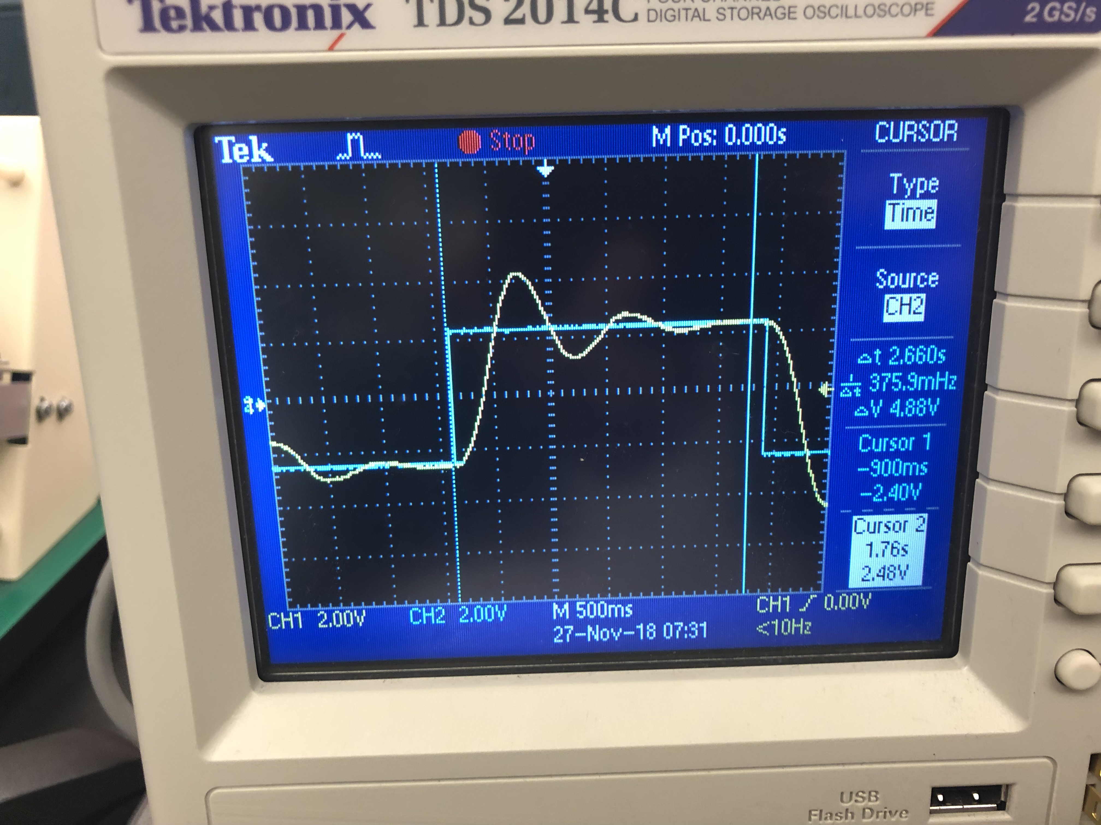
Figure. 10. P4 = 30%

When P4 = 50 the oscilloscope behavior can be seen from figure 15.
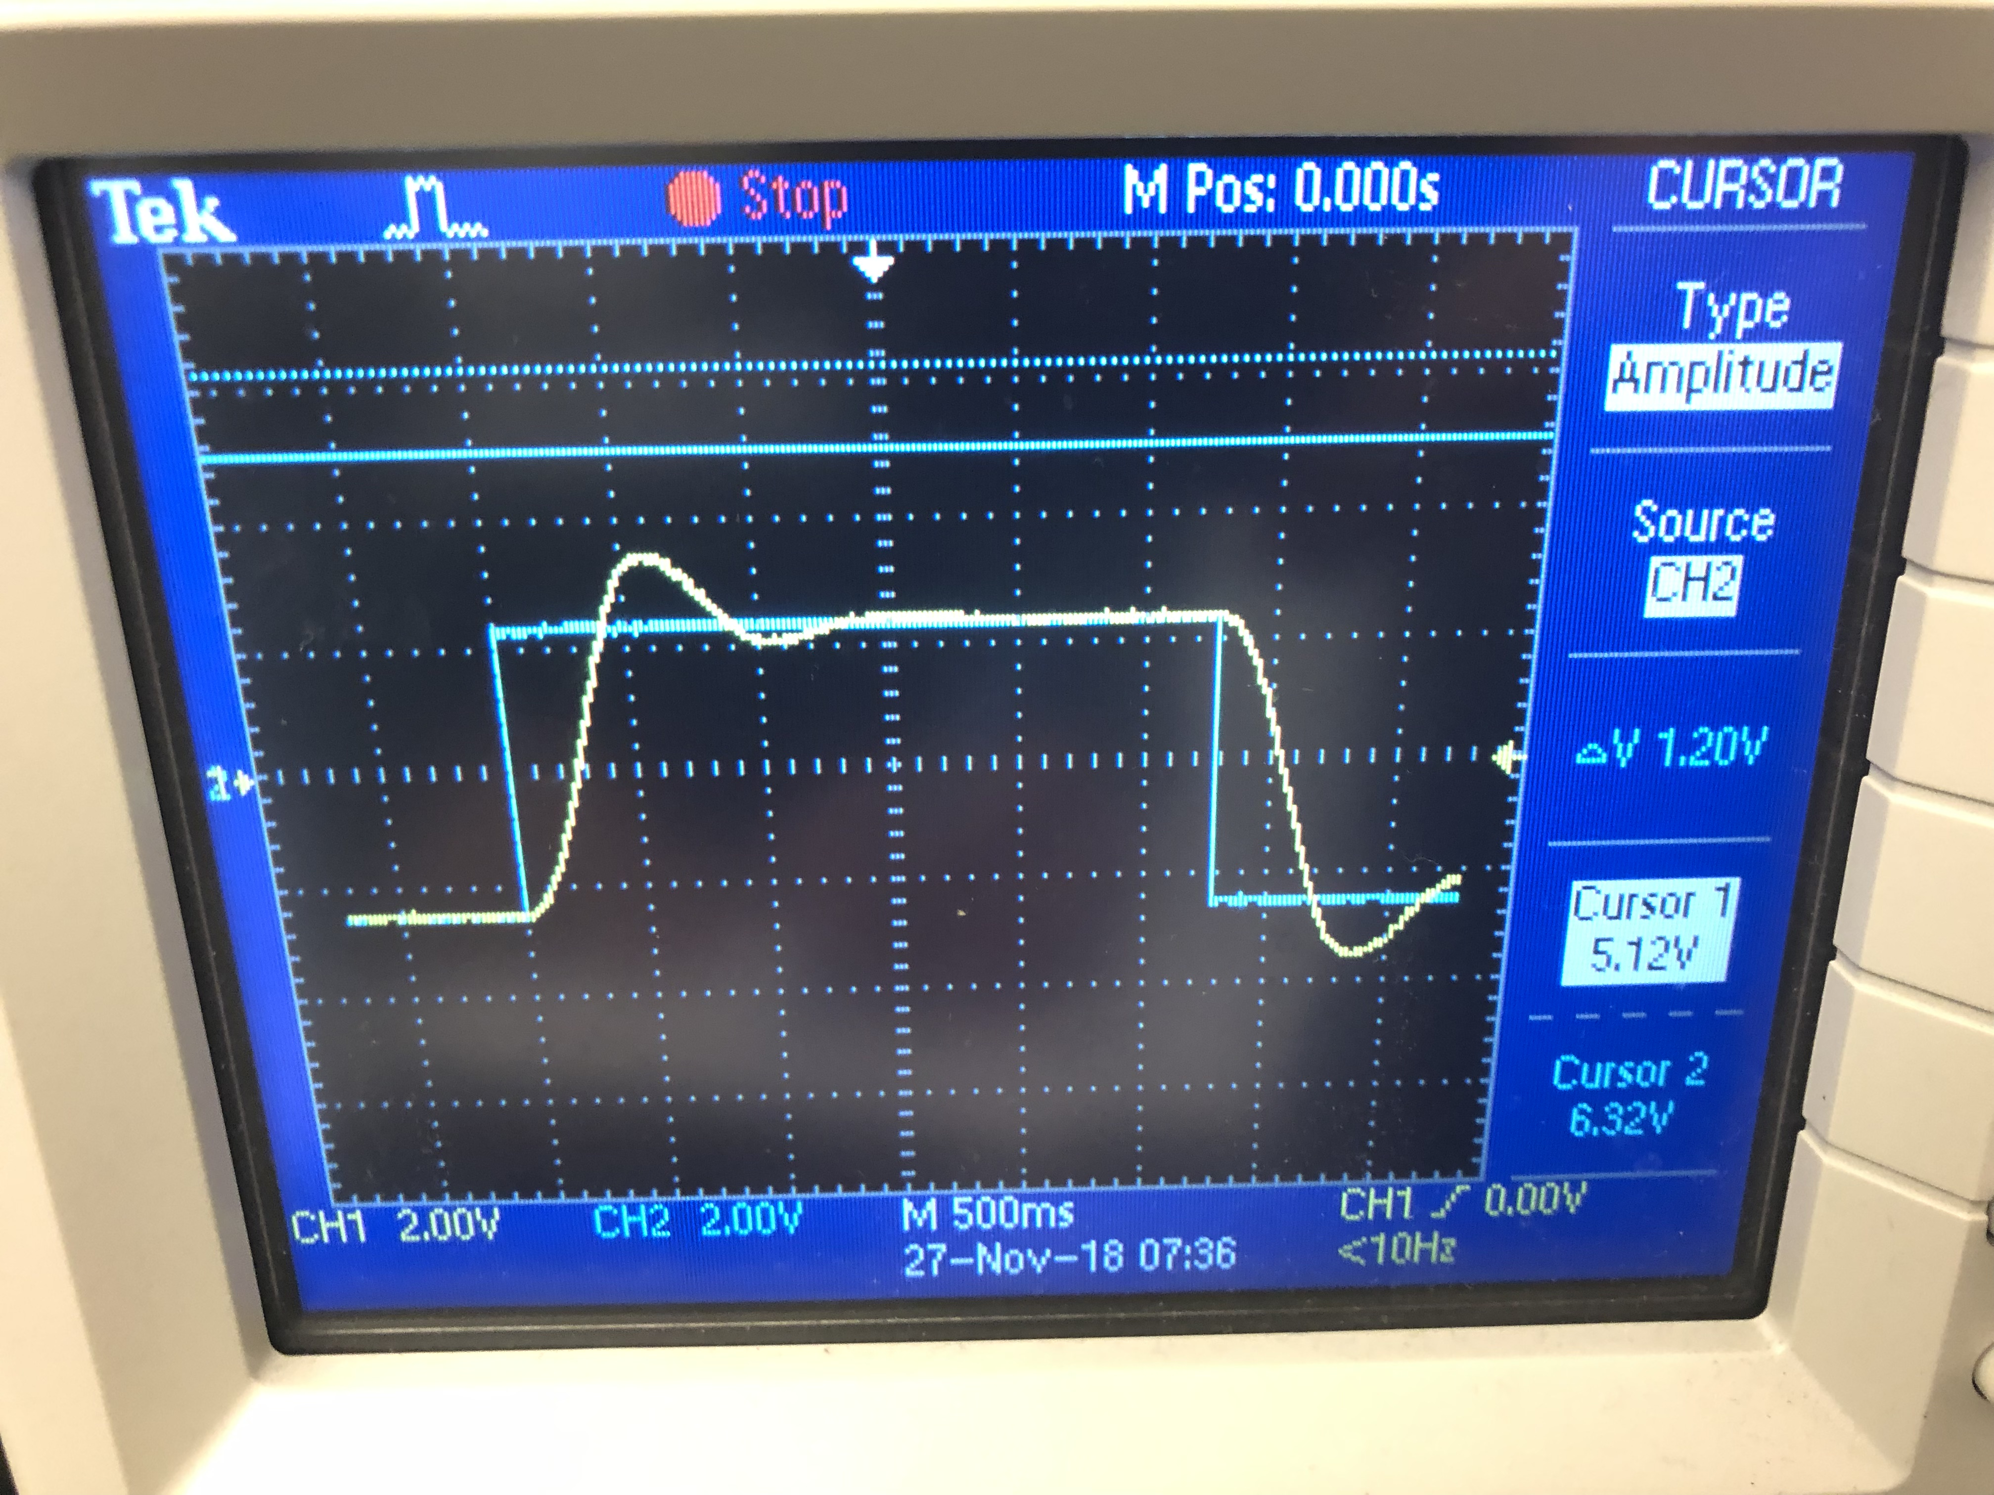

Figure. 11. P4 = 50%

When P4 = 70 the oscilloscope behavior can be seen from figure 12.
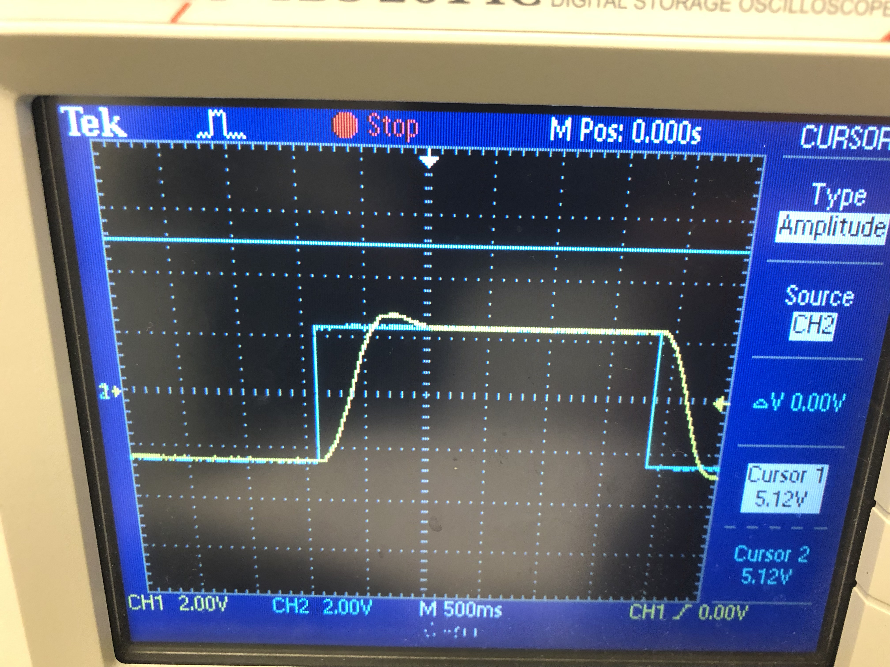
Figure. 12. P4 = 70%

When P4 = 100 the oscilloscope behavior can be seen from figure 17.
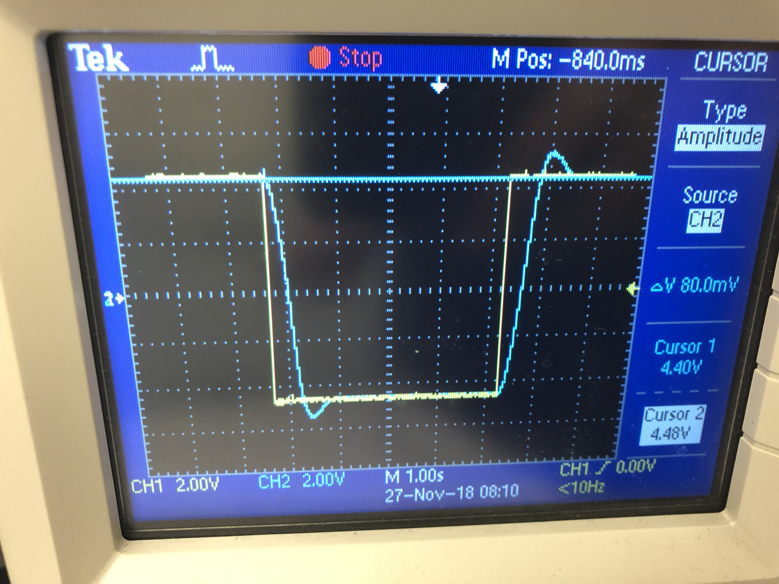
Figure 13. P4 = 100%

Table 1. PD characteristic table
P4 | Delta V |  | Ts | ess
0% | - | - |  |  | -
30% | 1.92 | 2.66 |  |  | 80mV
50% | 1.20 | 2.06 |  |  | 80mV
70% | 480 mV | 1.64 |  |  | 80 mV
100% | 0 | 1.32 |  |  | 0

PID controller:
The following figure 18 is related to a PID controller.
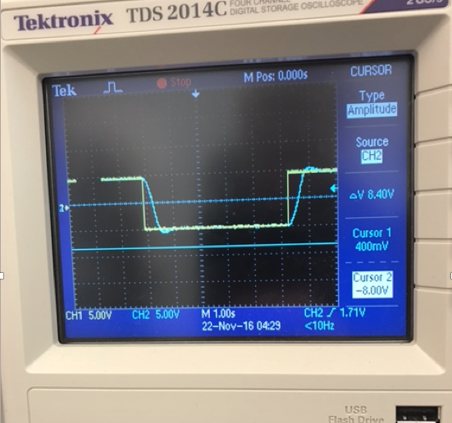
Figure 18. PID controller

Table 2. Characteristic table of PID
Gain (%)  P4 & P5 | Ts |  | Delta V |  | ess
0%, 0% | 4.6 |  | 4.20 |  | 400 mV
20%, 30% | 3.68 |  | 3.20 |  | 200 mV
50%, 50% | 3.0 |  | 2.23 |  | 160 mV
80%, 80% | 1.76 |  | 980 mV |  | 80 mV
100%, 100% | 1.40 | 800 mV |  | 80 mV

Discussion:
Initially, the observation was started with observation 1 considering channel 1. According to figure 5, the triangular wave was the input voltage and the square wave was the output voltage. The derivative of the input is now the output
Figure 6 is for the sinusoidal waves related to channel 1 and channel 2. The two input and output graphs can be clearly identified separately from the different colors.
When considering observation 2, it is related to the integrator. Figure 7 is related to channel 1 and the shape of the input curve was a square shape, while the output curve was kind of a triangular wave.
When considering the PD control, starting with P4 equal to zero, which is the P controller. If P4 equal to zero, it can be seen clearly that we will end up with a lot of oscillations as shown in figure 9. When P4=30% we will have fewer oscillations as shown in figure 10 comparing to figure 9. Moreover, When P4=50% we will have fewer oscillations as shown in figure 11 comparing to figure 10. When P4 reaches 70% almost no oscillations will be as shown in figure 12. Finally, when P4 reach 100%, it will be no oscillations at all as shown in figure 13.

P Control - Output power is directly proportional to control error. The higher the proportion coefficient, the less the output power at the same control error. Proportional control can be recommended for fast-response systems with a large transmission coefficient. To adjust the proportional controller you should first set the maximum proportion coefficient wherein the output power decreases to zero. When the measured value is stabilized, set a specified value and gradually reduce the proportion coefficient and the control error will decrease. If there are periodic oscillations in the system, the proportion coefficient should be increased so that control error is minimal periodic oscillations decrease to the limit.
PID Control - Output power equals the sum of three coefficients: proportional, integral and differential. The higher the proportion coefficient, the less the output power at the same control error. The higher the integration coefficient, the slower the accumulated integration coefficient. The higher the differentiation coefficient, the greater the response of the system to the disturbances. The PID controller is used in inertial systems with a relatively low noise level of the measuring channel. The advantage of PID is fast warm-up time, accurate setpoint temperature control and fast reaction to disturbances. Manual tuning PID is extremely complex, so it is recommended is to use the autotune function.

